Twiddle Mat Embroidered Pattern

Guidelines:
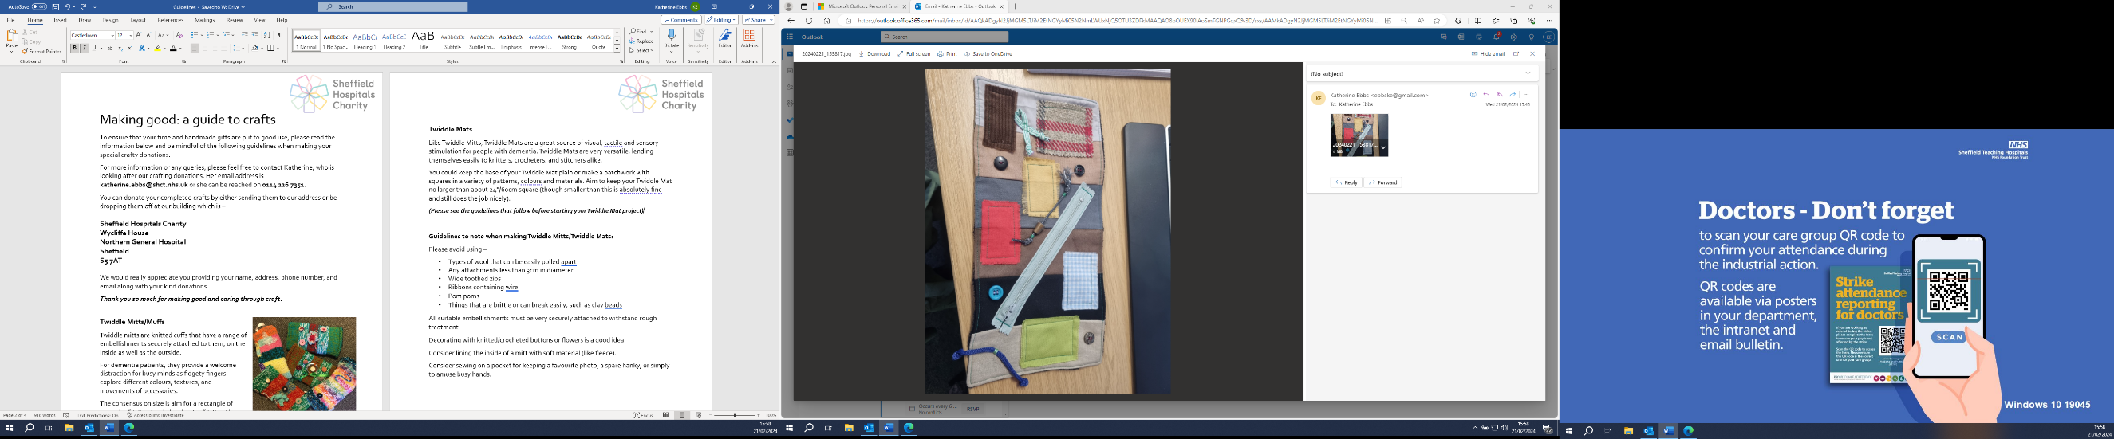
Please avoid using –
- Types of material that can be easily pulled apart
- Any attachments less than 3cm in diameter
- Wide toothed zips
- Ribbons containing wire
- Pom poms
- Things that are brittle or can break easily, such as clay beads
All suitable embellishments must be very securely attached to withstand rough treatment.
Decorating with knitted/crocheted buttons or flowers is a good idea.
Consider sewing on a pocket for keeping a favourite photo, a spare hanky, or simply to amuse busy hands.

Required:
Sewing machine
Embellishments (e.g. buttons, ribbon, plaits, crocheted flowers, crocheted buttons – things that can be ‘twiddled’ and won’t break or come apart! Please avoid using ‘hairy’ wool that can come apart if tugged)
Stiff stabilizer, fusible on both sides. – 1 piece 24 X 19 inches or 56 X 47 cm
Fabric - 2 pieces (front and back) - 24 X 19 inches or 56 X 47 cm

Instructions:
Lay first piece of fabric right side up on a table.
Lay second piece of fabric, right side down (on top of first fabric).
Lay stabilizer on top of fabrics.
Sew around and leave one side open.
Turn fabric layers inside out.
Now you have the interfacing between the two layers of the mat fabric, finish mat’s open side by folding inwards and sewing shut.
Iron the mat well to allow the interface to fuse.
Sew all around the 4 sides of the mat once more to finish the base.
Decorate with your imagination; anything interesting and within the guidelines is suitable. Embellishments like buttons, ribbon, plaits, crocheted flowers, crocheted buttons – things that can be ‘twiddled’ and won’t break or come apart! Please avoid using ‘hairy’ wool that can come apart if tugged)
Please check there are no loose threads and make sure that all the embellishments are sewn on tight so they cannot be pulled off – bear in mind that the pulling/twisting strength of an agitated patient may be stronger than you think! If in doubt, add a few more stitches to make things extra secure.

Thank you to Golden Carers for the pattern: How to Make Sensory Blankets for Dementia Care (goldencarers.com)

Please either arrange a drop off time or send all completed Twiddle Mats to:
Office Se6, Leah's Yard, Cambridge Street, Sheffield, S1 4HP

